📊 Dashboard Analysis: Online Retail Sales
📌 Overview
This dashboard provides a complete view of online retail sales performance by combining multiple key metrics such as revenue, quantity, and regional performance. It helps in understanding business trends and making data-driven decisions.

🎯 Purpose of Dashboard
The main purpose of this dashboard is to:
- Track overall sales performance
- Analyse monthly trends in revenue and quantity
- Compare sales across different regions
- Identify high-performing periods and locations

🔹 1. Region Wise Quantity
This section compares product sales across different regions.
It helps to:
- Identify top-performing regions
- Understand geographic demand

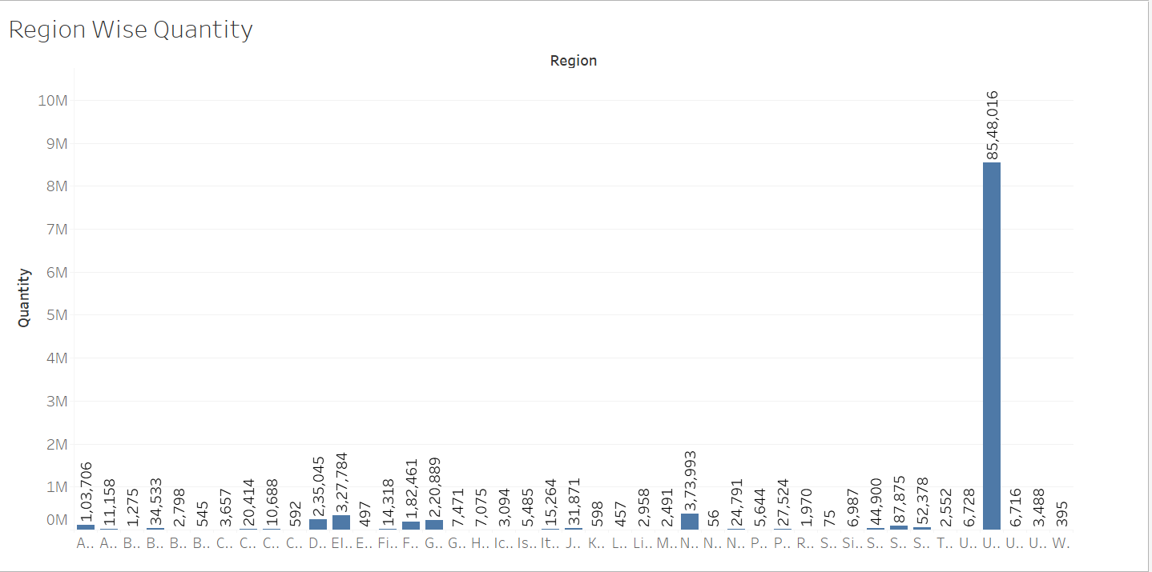

🔹 2. Month Wise Quantity
This part displays the total number of products sold per month.
It helps in:
- Understanding customer demand
- Identifying high-sales periods

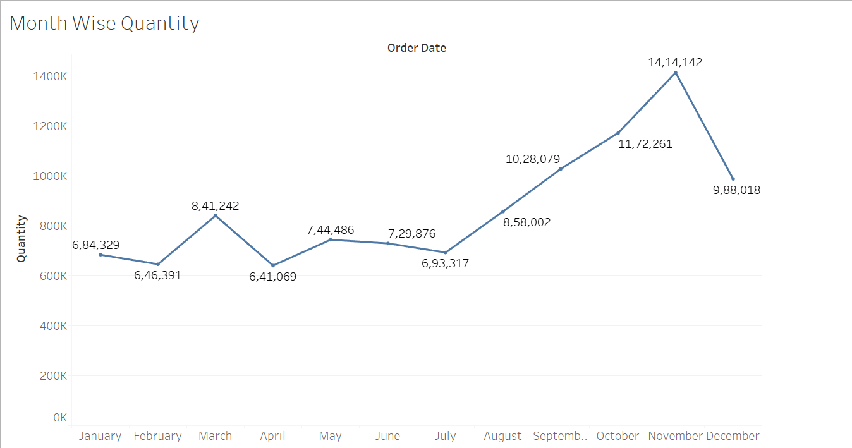

🔹 3. Month Wise Revenue
This section shows the total revenue generated each month.
It helps identify:
- Peak sales months
- Seasonal trends
- Business growth over time

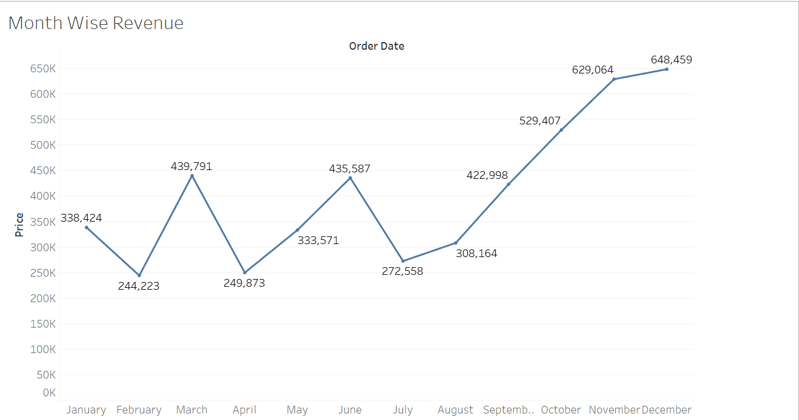

🔹 Monthly Sales Trend (2010–2011)
This chart shows the total sales quantity for each month in 2010 and 2011.
It helps in:
- Understanding monthly sales performance
- Comparing sales between two years
- Identifying peak and low sales months

